This binary tree is useful for searching that what the naming convention as BST. The left subtree node will be smaller, and the right subtree node will be greater than the root node. So, this is more like binary search.

* **This is useful for searching an element in less number of comparisons.**
* Binary search is applied on a single array in a list of elements. But this is upon binary tree. So, the behavior is similar to binary search.
* So, the search time depends on the height of a tree.
* BST will not have duplicates.
* **If we take In Order traversal of Binary Search Tree, we will get the list of elements in sorted order.**
* If we have some nodes, then how many different binary search trees can be created for the same set of nodes.

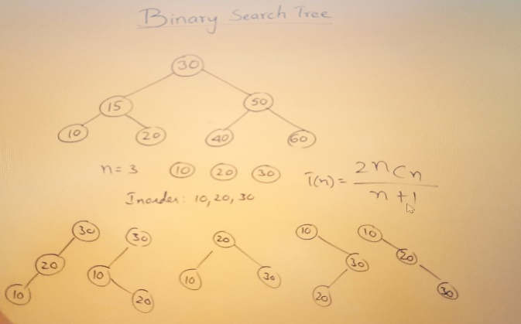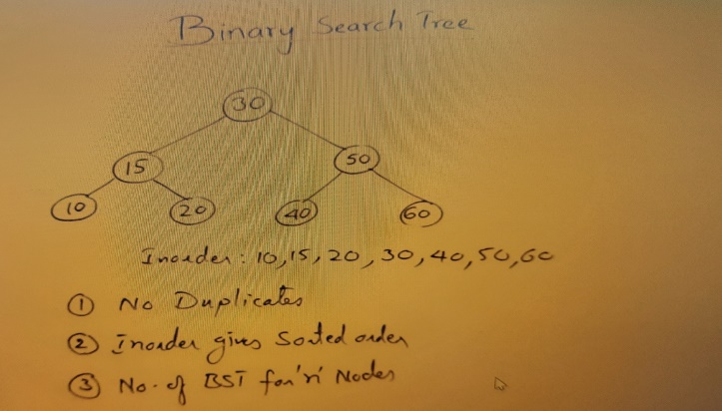

**Let’s us see how we can represent the BST**

BST represented using Linked representation.

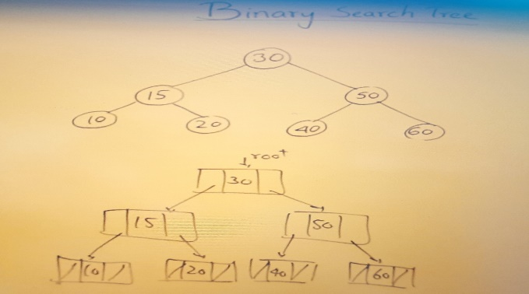

* **Searching in a Binary Search Tree**

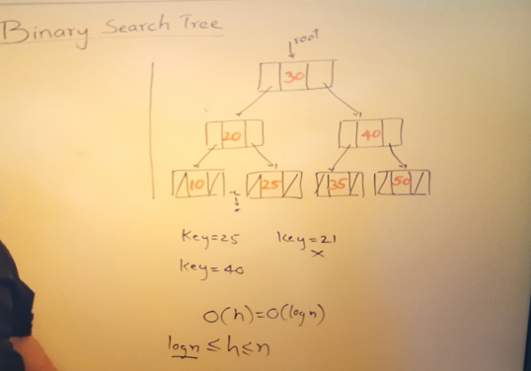

* Searching in a BST using Recursion—

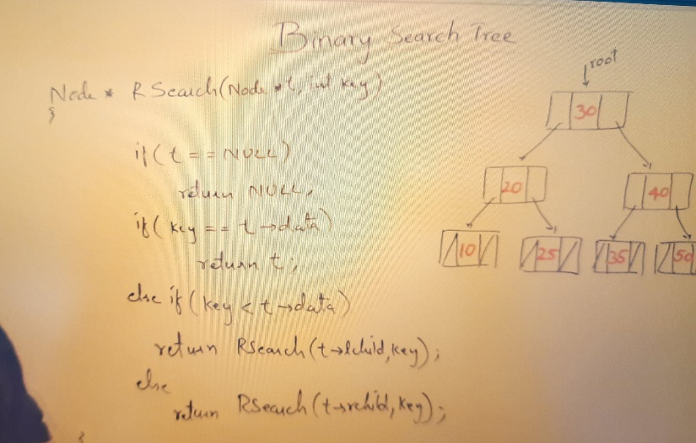

* Searching in a BST using Iterative approach---

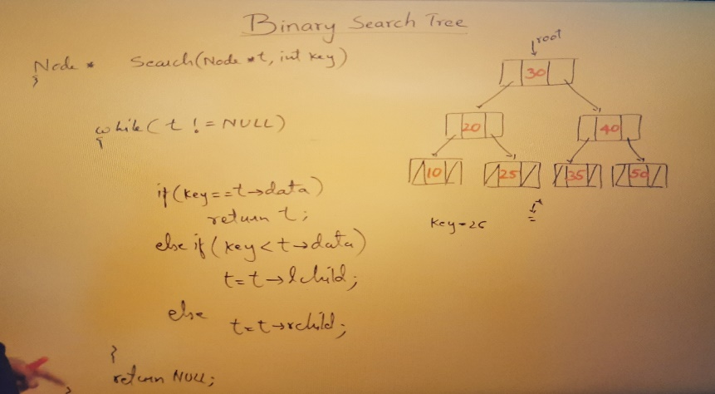

* **Inserting in a Binary Search Tree**